Corril Ochsenbein
Fall Semester 2012
English 2010
It’s Time To Make A Change

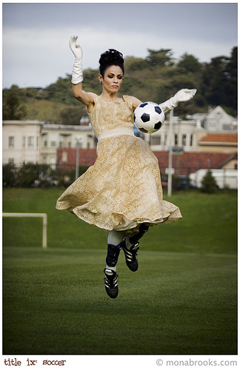
What is it about humans that make us believe that there is something that is right opposed to something else that is wrong? Not because it is totally and completely wrong, but because society disagrees with the idea. The issue that I am specifically questioning is the controversy and dispute over coed teams for sports. On June 23rd, 1972 Title IX was put in place to prohibit sex discrimination in any educational program or activity receiving any type of federal financial aid (“Title IX Legislative Chronology “par. 1). This resolved the issue of women not being able to play sports at that time in the past where that was an issue.
Today the problem isn’t women playing sports, but the fight between women and men playing sports together. Because Title IX was made with the specific intention to dissolve discrimination when it came to women, in our day and age this discrimination falls under the category of playing with or against the opposite sex. Many people think that the issues associated with Title IX where resolved when this was put in place. Though this act had done a lot to change this, it still hasn’t fixed all the glitches that are involved with the issues for women and sports. It has been found that schools are providing 1.3 million fewer chances for girls to play sports in high school as compared to boys. While more than half of the students at NCAA schools are women, they receive only 44% of the athletic participation opportunities (“Athletics under Title IX”par. 3).
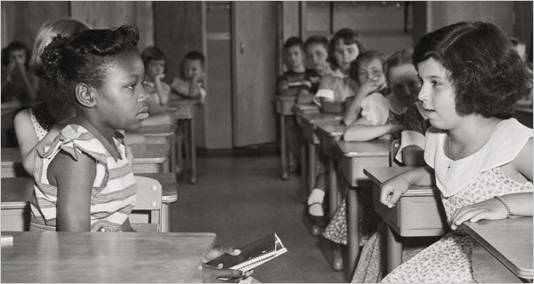
Things may have changed for that past generation, but they still aren’t where they should be and it is our generations turn to make that change. If people (guys and other races) were to look at this issue the way women do, their attitude might change, as they would see how much this issue really means to us. Say that it were the men who were being discriminated against, would the problem become more relevant and be more important if it was switched around? Other women may see this issue differently than I do, but when I see separate sports teams that are based on gender I feel like we are being discriminated against, like I am sure the black people felt when they had no rights or freedoms. The action is no different than when African American’s where put in different schools than whites. If there was something wrong with that and a change needed to be made there, wouldn’t you think that a change should be made for women with the discrimination that goes on?
Everything as we know it wouldn’t have to change completely, but there should be the opportunity for athletes to play with the best or any other team out there, no matter what gender you are. This is only the beginning and something tells me that it won’t be the end, not for a long shot. The Mighty Cheetahs, a girls’ soccer team, made up of eight-year old girls signed up to play in the boys division. Their coach had done this with the hope that the girls would experience losing a game or even tying, as they had won the tournament two years in a row with scores that seemed to show no real competition (David Hinckley par. 4). When they entered the tournament it was the parents who had seemed to have more of a problem than the boys themselves. Some parents were yelling things like, “you kick like a girl” to the girls on the opposing team. At first that was seen as a put down, but after the girls team had beat the boys, or better said in the terms the boys used, “creamed them”, that statements totally changed the meaning of the statement you kick like a girl (Documentary “Kick Like A Girl”). Statistics show that female sports do not carry the same weight as male sports (Jean Cassel par. 2).
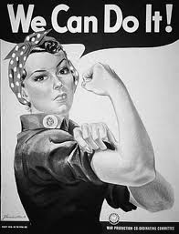
It is time for schools, colleges, and professional sports team to change this. If a girls soccer team (that is made up of kids that are 8 years old) can do it, then so can the rest of America. Over time America has earned the title, the place where dreams are made. For many years we have upheld to that standard, but if something like this doesn’t change it could deplete the title that has been earned. The United States is so unique in the fact that we lead the way for change.
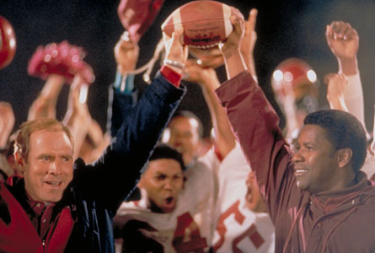
In doing this we would be creating so many opportunities for our country. Athletes that play together would have to learn how to adapt to how other genders play. I have played basketball for a long time now. When I first started playing I was in third grade and the first time I played wasn’t with girls, it was with the boys. It has been that way ever since. The reason I bring this up is there are so many differences between how the two play. Because I played with the boys as well as with girls (as I was on the girl’s high school team) I was able to see both sides and learned how to play with both. Bringing the two genders together could help us to build some of the strongest athletes that we have ever had. Look at the movie Remember the Titans. It wasn’t just about learning how to bring the two together, but also dealing with the differences that they encountered.
What guy would ever be okay with losing to a girl? This fact alone would increase the competition and raise the level of commitment. Despite the fact that we are built differently than guys are, does not mean that we can’t beat them in sports. The Mighty Cheetahs proved this when they went up against the boys team that they played. More than anything I see this as a pride issue for the guys that play sports. I think that they have the opinion that if we play with girls, than we are lowering ourselves down to their level. If no one ever gives it a chance or tries it, how will they know the outcome? Guys need to swallow their pride, and the girls need to earn the respect and right to play with them. So why not give us chance?

Work Cited Sources
"Athletics Under Title IX." TitleIX.info. N.p., n.d. Web. 4th Dec. 2012. <http://www.titleix.info/10-Key-Areas-of-Title-IX/Athletics.aspx>.
Cassel, Jean. "Gender Discrimination in Sports." LIVESTRONG.COM. Livestrong, 14th June 2011. Web. 4th Dec. 2012. <http://www.livestrong.com/article/247625-gender-discrimination-in-sports/>.
Hinckley, David. "HBO's 'Kick Like a Girl' Shows Girls Taking a Shot at Boys' Soccer." New York Daily News. Daily News, 28th May 2009. Web. 4th Dec. 2012. <http://articles.nydailynews.com/2009-05-28/entertainment/17923411_1_boys-girl-thursday-night-girls-sound>.
"Kick Like a Girl." HBO. N.p., n.d. Web. 4th Dec. 2012. <http://www.hbo.com/documentaries/kick-like-a-girl/index.html>.
"Title IX Legislative Chronology." Women's Sports Foundation. N.p., n.d. Web. 0 Dec. 2012. <http://www.womenssportsfoundation.org/en/home/advocate/title-ix-and-issues/history-of-title-ix/history-of-title-ix>.

