Brandon Lukens
ENGL 2010
T H 11:30 – 12:50
09-18-12
Is America the Land of Dreams?
We all have dreams. Your dream could be to have millions and live like a celebrity, travel the world, or to simply have a family while working your dream job. That is my dream, to have my own family and work my dream job as an elementary school teacher. Being able to teach children and have a lasting impact on their lives, as a teacher, is something I have always wanted to do with my life. Throughout my middle school and high school years I would always go to the younger grades and volunteer my time. I always felt so amazed when I would come to the school and see the kids get excited that I was there. Seeing the kids’ eyes light up as they finally understood a concept was the most amazing moment to me; this was when I knew I wanted to become a teacher. As I completed high school I knew I wanted to go into teaching so I could have those experiences throughout my entire life. When I entered college I began the work into getting my elementary education degree.
After starting school I eventually met the love of my life. Even though we met under unusual circumstances I knew right away that I wanted to spend the rest of my life with her. In the summer of 2012 I was able to propose to her at the Riverwalk in San Antonio, Texas and that will forever be the greatest day of my life. Seeing the smile on my fiancé’s face as I put the ring on her finger is an image that will always be able to bring a smile to my face. Knowing that somebody will always be by my side for the rest of my life is an amazing feeling. After the joy of proposing began to wear off and I had to come back to reality, I began to rethink how I would be able to support my future as a teacher. So, I started to do some research into the average starting salary for a teacher. According to the Utah Education Association the average starting salary for a teacher in Utah with a Bachelors degree is $33,117 for 2010-2011 (see table 1). This information not only shocked me greatly, but also greatly worried me at the same time. I started to become greatly concerned not only with my future job but also my future family.
At my current job I am making $40,000+ per year in a job that requires no college education. Once I get my college degree however, I am going to be taking a massive pay cut just to go to my dream job. I have constantly thought to myself how can I take a pay cut to become a teacher when I am getting married and starting a family soon. In an economy that is showing no signs of recovery, taking any kind of pay cut is hard to consider. Getting married brings about new finances for me to consider as I now have to think in both of us, not just myself. Thinking about having a baby is even harder to consider at this time because Forbes.com recently reported that having a baby in 2012 will cost $234,900 (Touryalai, par 2), and that is just for basic necessities to raise the child till the age of 17. This number is staggering and makes me think, “How can I get my dream job and still support a family on such a small income in a tough economy?”
What makes teachers salaries even harder to swallow is how much teachers need to spend on school supplies for their classroom, and it has to come out of their wallets. How can teachers be expected to support a family and also buy their own supplies for their classroom on such a low income? I have to think to myself how can I provide my future students with the best education possible when I may not be able to provide the best life for my family. With the world economy not getting any better it makes the situation of money even more problematic. Now I know there are federal programs that can help provide teachers with extra money to help get proper supplies for their classroom but it is still tough to think that not only am I going to be supporting a family but also having to provide my own supplies to do my job.
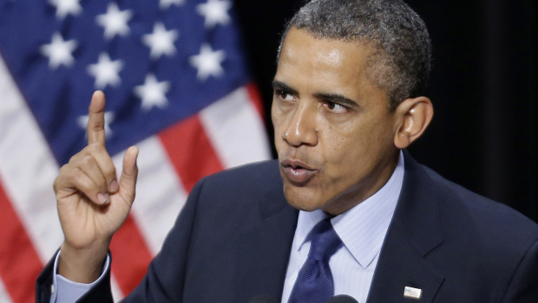
President Obama. CBS News. 2012.
President Obama has stated “there’s nothing more important to our country’s future than the education we give our kids” (Jackson, par 9). Hearing this come from the President is promising because it shows that the situation is being taken seriously. He even stated that he is “running to make sure that America has the best education system on earth, from pre-K all the way to post graduate” (Associated Press, par 5). In the 21st century countries are advancing faster and if the U.S. wants to stay at the top we have to ensure that we are taking care of our education system. Having the President behind teachers I believe will help make things better because job satisfaction is slowly falling in the teaching world.
The Huffington Post recently reported that teacher satisfaction with their job has fallen from 59% to 44% (Resmovits, par 6). Teacher’s pay, classroom conditions, and less freedom are just some of the conditions that are leading to decreased teacher satisfaction. There are currently teachers who are still working as teachers even though they are completely unhappy in their position. This makes things even worse for the students as teachers may not be providing the best experience for the students. As someone who is currently miserable in his current job these numbers are worrisome. Through my entire life I have always wanted to be a teacher and thought that would make me happy but yet when I see these numbers I have to think to myself will I really be any happier? Even though there are many factors that are associated with job satisfaction I know that pay is something that can help make things better. Once I am able to get into the teaching world I know that I will be stressed if I am asked to take on too much while making less. This is where I have been hoping to see some change with the upcoming election.
As the election of 2012 is starting to come into full swing, I am hoping to see the candidates dive more into how they are going to help teachers. Teachers are everywhere in our lives and even the candidates, Mitt Romney and Barack Obama, would not be where they are today if they did not have a teacher to help teach them when they were children. There is an extreme disparity in how teachers are paid and it needs to be addressed. Even though they are only asked to work 9 months out of the year, as they are given summer off, they are still asked to do an incredible amount. As teachers continue to feel that they are not being compensated properly for what they are being asked to do, negative actions could begin to happen. Even at this time there are teachers currently striking in Chicago due to how they are compensated and evaluated. As a student who wants to pursue his dreams of becoming an elementary school teacher and who is also starting a family soon, I want to see how things are going to change in the world of education. America is the land of dreams but through my experiences and research I am starting to wonder if I can really achieve my lifelong dream.
Chicago Teachers Strike. New York Times. 2012

Table 1: Bachelor’s Degree Salary Schedule Changes 2011-2012 With Comparitive Figures For 2010-2011.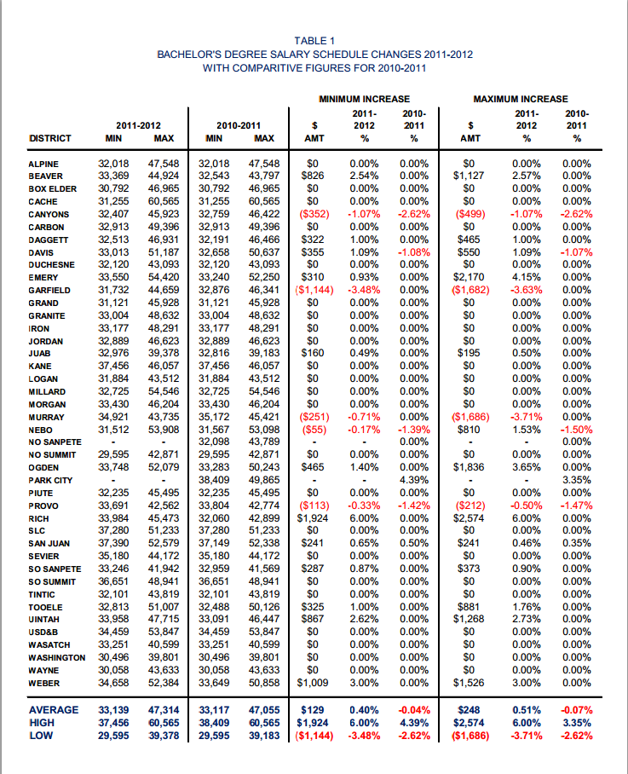
Source: Utah Education Association, 2010-2011 Teacher Salary Schedules & Comparisons, Utah Education Association, 2010, Web, table 1.
Works Cited
Davey, Monica. “Teachers’ Strike in Chicago Tests Mayor and Union”. The New York Times. 10 Sep. 2012 Web. 16 Sep. 2012
Jackson, David. “Obama says plan will save teachers’ jobs”. USA Today. 18 Aug. 2012 Web. 16 Sep. 2012
N.A. “Education Olympics: How Does America Rank Compared To Other Countries?”. Huffington Post. 27 July 2012. Web. 16 Sep. 2012
N.A. “Obama plans $1B effort to build “Master Teacher Corps” of elite math, science teachers”. CBS News. 18 July 2012. Web. 16 Sep. 2012
Resmovits, Joy. “Teachers’ Satisfaction Tanks On Survey When Higher Expectations Come With Fewer Resources”. Huffington Post. 21 Mar. 2012. Web. 16 Sep. 2012
Touryalai, Halah. “Have $235,000? That’s What It Costs To Raise A Kid Today- Before College”. Forbes. 6 June 2012. Web. 16 Sep. 2012
Utah Education Association. “2010-2011 Teacher Salary Schedules & Comparisons”. My UEA. 2011. Web. 16 Sep. 2012

